CONTENTS
________________________________________________________________________________
- HISTORY OF THE CONSUMER COUNCIL OF ZIMBABWE ........................................2
- ORGANISATIONAL VISION AND OBJECTIVES............................................................3
- BOARD MEMBERS ........................................................................................................4
- SENIOR MANAGEMENT................................................................................................5
- STATEMENT FROM BOARD CHAIRMAN .................................................................6-8
- CCZ ORGANISATIONAL STRUCTURE.........................................................................9
- REGIONAL COMMITTEE MEMBERS...........................................................................10
- CCZ STAFF MEMBERS...........................................................................................11-13
- FUNDING ......................................................................................................................14
- RESEARCH..............................................................................................................15-16
- EXECUTIVE DIRECTOR’S REVIEW ...........................................................................17
- FOCUS FOR 2016.........................................................................................................18
- CONSUMER EDUCATION .....................................................................................19-22
- MEDIA PUBLICITY. .................................................................................................22-24
- PROMOTIONAL ACTIVITIES ..................................................................................24-26
- INTERNATIONAL WORKSHOPS............................................................................26-27
- MEMBERSHIP .........................................................................................................28-29
- COMPLAINTS RECOVERIES .................................................................................30-31
- LOBBYING AND ADVOCACY .................................................................................32-34
- CONTACT DETAILS .....................................................................................................35

- HISTORY OF THE CONSUMER COUNCIL OF ZIMBABWE

The formation of the Consumer Council of Zimbabwe can be traced to as far back as 1955 and it was spurred by economic problems resulting from increased cost of living and violation of manufacturing standards.

The formation was spearheaded by two prominent Women’s Organizations, which had active interest in consumer issues. These were the National Women’s Organization and the Federation of Women’s Institute.

The then Salisbury Consumer Movement group was aimed at ensuring that consumers would not only get value for their money, but that primary producers and manufacturers produced items of high standard which could compete with imported processed foods and manufactured goods.

It is against this background that the Consumer Council of Zimbabwe (CCZ) was born in the structure we know today on the 5th of December 1975. Over the years, the organization has expanded and restructured its policies in order to enhance its effectiveness. Its four major areas of concentration are complaints handling, consumer education, lobbying and advocacy, and research.

2. ORGANISATIONAL VISION, MISSION & OBJECTIVES __________________________________________________________________________

VISION

As the Consumer Council of Zimbabwe, we shall strive for a fair deal for our consumers within the marketplace.
MISSION
The Consumer Council of Zimbabwe strives to become a visible and highly effective consumer empowerment and protection organization in the country that unconditionally upholds the interests of all its stakeholders. The Consumer Council of Zimbabwe shall achieve its mission through the establishment and management of effective networks with fellow consumer organizations worldwide, and through the management of a competent and well-motivated staff.

MANDATE
The mandate of the CCZ is to protect consumers, protect manufacturing standards and improve consumer awareness through education and to settle disputes between consumers and suppliers of goods and services among other objects.

- BOARD MEMBERS
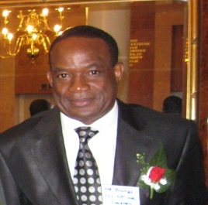

Mr P. Bvumbe Dr Ruzivo

National Chairperson Mashonaland Chairperson  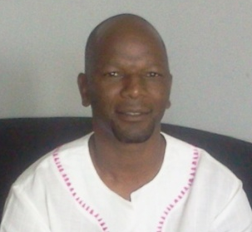
Mr Mukusha Mr Nyoni
Masvingo Chairperson Matebeleland Chairperson

Mr Mujajati Mrs Chanetsa
Ministerial Appointee Manicaland Chairperson


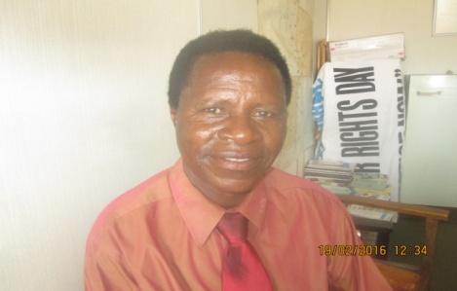

Mr Manyongo Ms Rosemary Siyachitema
Midlands Chairperson Ex-Officio

4. SENIOR MANAGEMENT


Ms Rosemary Siyachitema Mrs Rosemary Mpofu
Executive Director Deputy Executive Director


Mr Henry Musongwe

Finance and Administration Manager

STATEMENT FROM BOARD CHAIRMAN

The year 2015 was characterized by a poor performance of the economy, and the Government in response came up with a 10 (ten) point plan for economic growth on the 25th of August 2015 .The following is our observation on the impact of the economic thrust on consumers in 2015 and the 2015 business plans.

a) Revitalizing Agricultural and Agro Processing Value Chain
This strategy was affected by the changes in the weather patterns, most areas received rainfall towards the begging of 2016 thus the food security at household level was threatened. Many families had to reduce their daily meals to once per day .The country will have to rely on importing maize to feed the nation, as this is the staple food for the majority of the consumer.

b) On Infrastructure Development In The Energy , Water Transport And ICT Subsector and Promoting Joint Ventures and Public Private Partnerships to Boost the Role and Performance of State Owned Companies
The government has moved positively and developed its arrears clearance strategy and re- engaged the World Bank Group, the International Monetary Fund and the African Development Bank. Although little progress was made, the government must not give up in seeking the bridging finance in order to enable the government to clear the debt it owes to these institutions as this will help to unlock funding for this strategy which will result in improved service delivery to the consumer to access clean and safe water , electricity , improved road condition , development of the ITC sector which is key to economic development and improvement of health care for the wellness of consumer .

Government has made great strides in the Look East Policy and a number of joint ventures have been signed in the energy, telecommunication and infrastructure development areas of the economy. We still look forward to the implementation of these deals as they will improve the economic climate of the country.

c) Encouraging Private Sector Investment and Modernizing Labours, Opening Special Economic Zones to Promote Foreign Direct Investment
In its efforts to address the ease of doing business that is the ease of investors can get investment licenses and permits including a relaxed visa regime, and security of investment and reforms to the Indigenization Act. Despite efforts by government in this area investment has remained low due to the high level of corruption and hostile political climate. Government needs to pursue its anti Corruption thrust.

The Amendment to the labour laws resulted in the dismissal of 30 000 employees adding to the already high level of unemployment which currently stands at 85 percent. The lifestyle of most household consumers have been seriously affected, as they can no longer afford to pay rent, school fees, buy basic food staff, afford medical bills and general upkeep of their families. Many consumers are in debt from an accumulation of utilities bills from the previous and current years. The demand for goods and services is now very low which will lead to further business closures due to the reduction of the buying power of consumers.

d) Restoring and Building of Confidence and Stability in the Financial Services Sector Government has come up with a financial inclusion strategy to broaden the participation of consumer through a literacy financial strategy that will help consumers to acquire knowledge, skills and make informed choices to take active action to improve their welfare and help improve consumer confidence, particularly low income households. Despite these challenges CCZ continued with its programs in consumer protection in spite of the dwindling income revenue flows. The road to resolving consumer issues was not an easy one as every consumer looked forward to meet the current challenges of their own poverty with dignity and in conditions of safety, social justice and equity in the market place. The economy continued to be constrained.

e) Corporate Governance
In 2015, the Board only managed to meet once throughout the year because of financial constraints. CCZ has for the past years found itself challenged to hold the necessary statutory constitutional requirements meetings at National level. Regional committees continued to meet in their respective areas on a monthly basis despite the non availability of funds. We commend you for your efforts and hard work in ensuring that policy issues were resolved and for your continuous guidance. We were also not able to train and implement the code for good corporate governance in spite of this draw back. The Executive Committee met to ensure that some of the compliance issues were carried out. This issue remains as work in progress for the coming year.

We also acknowledge that there are arrears in your monthly sitting allowances board fees. We have engaged our parent Ministry of Industry and Commerce about the outstanding board fees which will be paid when funds are made available by the Ministry of Finance. Despite these challenges, the organization reaffirms its commitments to comply with the code of good corporate governance.

f) Way Forward
We need to think outside the box on to mobilize funds for sustaining the organization, Board and staff .We should be innovative. The process to move the organization towards greater financial sustainability is not an easy one. We have in the past years worked hard towards this goal, more hard work still needs to be done to look for projects funding. We need to increase our fund raising activities in 2016. Let us continue to work with our private and public sector partnerships as we did well in this area in 2015.

We hope the Consumer Act will be enacted into law this year as we have finalized the entire draft bill.

Lastly, work on the consumer surveys still need to be carried out to come out with an updated Basket which reflects the current US Dollar economy.

I would like to take this opportunity to thank the Zimbabwean Government, our parent Ministry, Consumers International, OSISA, Mimosa Mining Company for giving us moral and financial support in the year 2015.

Our most sincere thanks go to our consumers, staff and other stakeholders for their support throughout the year.

Special thanks to our Board members for their continued guidance and insight which ensures confidence in our movement.

6. CCZ ORGANISATIONAL STRUCTURE

EXECUTIVE DIRECTOR

DEPUTY EXECUTIVE DIRECTOR

FINANCE & ADMIN MANAGER

PA TO EXECU REGIONAL REGIONAL REGIONAL REGIONAL REGIONAL ECONOMIST
DIRECTOR OFF MASH OFF BYO OFF MASV OFF GWERU OFF MUTARE

EXECUTIVE COMPL/RES COMPL/RES COMPL/RES COMPL/RES COMPL/RES PR ADMINI
SECRETARY OFFICER OFFICER OFFICER OFFICER OFFICER OFFICE OFFICER

RECEPTIONIST/ RECEPTIONIST/ RECEPTIONIST/ RECEPTIONIST/ RECEPTIONIST/
TYPIST TYPIST TYPIST TYPIST TYPIST

DRIVER/ DRIVER/ DRIVER/ DRIVER/ DRIVER/
OFFICE ORDERLY OFFICE ORDERLY OF FICE ORDERLY OFFICE ORDERLY OFFICE ORDER

7. REGIONAL COMMITTEE MEMBERS

Name of Region | Chairperson | Vice Chairperson | Secretary | Vice Secretary | Treasurer | Committee Members
Manicaland | Mrs. Esther Chanetsa | Mr David Mutambirwa | Mrs Alice Marange | Mrs Nyembesi Chikwasha | Mrs Joyce Chawoyoka | Mr David Chimuka  Mr Fungai Mhlanga
Matebeleland | Mr Ntokozo Nyoni | Mr Rex Maseko | Mr Lancelot Maphosa | Ms Sithabile Tshuma | Ms Melisa Ndlovu | Ms Thandeka Nkomo  Mr Haback Masvaure
Midlands | Mr Kepie Manyongo | Mr Nathaniel Chiponda | Ms Feziwe Vundhla | Mrs Getrude Dube | Mr Levious Hundivenga | Mr Albert Phiri  Mr Wilson Ngirazi
Mashonaland | Dr Munetsi Ruzivo | Ms Nyaradzo Tavarwisa-Munyoro | Mrs Editor Matamisa |  | Mr Moeketsi Molai | Ms Thandekile Mkwananzi  Ms Josephine Machiwenyika
Masvingo | Mr Jowel Mukusha | Mrs Entrance Takaedza | Ms Gamuchirai Chikasha | Mr Enerst Munemo | Mrs Joyce Mhungu | Mr Prosper Dendere  Ms Elizabeth Madhuku

8. CCZ STAFF MEMBERS

Manicaland Region

Manicaland Region Staff: Mr Barnabas Masamvu-Regional officer (right), Ms Rudo Zisengwe- Receptionist (sitting), Mr Timothy Mero - Student of Attachment

Midlands Region
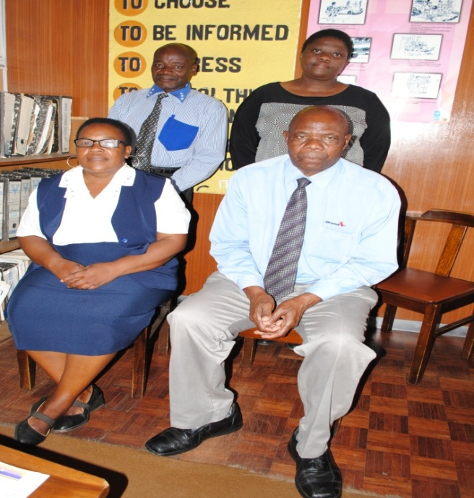
Midlands Region Staff: (sitting) Mrs Chiedza Harunanshe – Regional Officer, Mr Gerald Chirumhanzi – Driver, (standing) Mr Allois Mutarangire – Complaints Officer, Miss Filda Magaiza – Receptionist

Masvingo Region
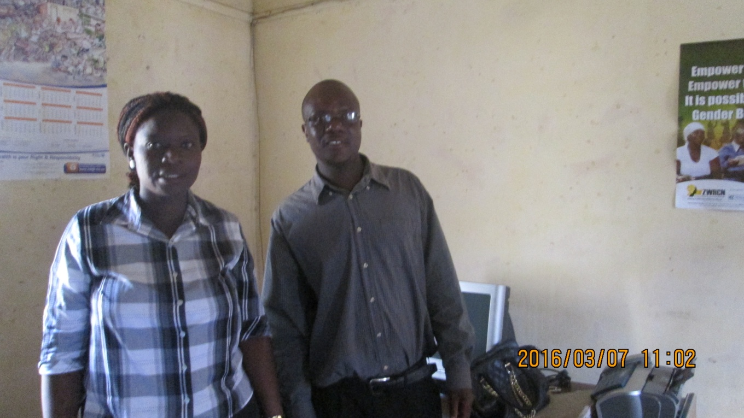
Masvingo Region: Mr Ndumiso Mgutshini – Regional Officer and Ms Ketai Zvinonzva – Receptionist

Matabeleland Region
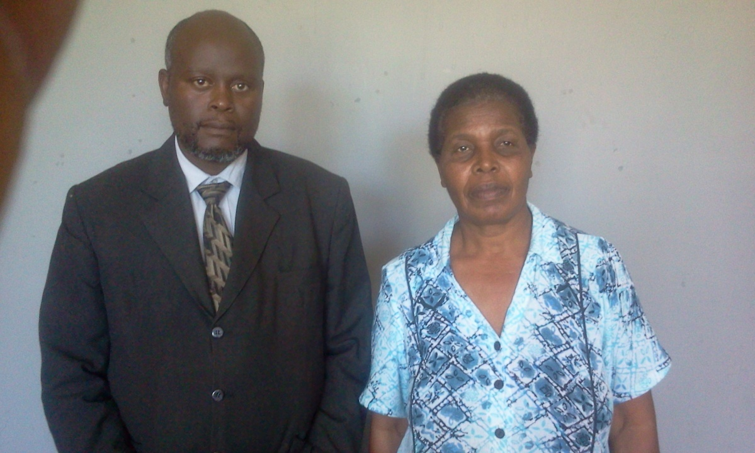

Matabeleland Region: Mr Comfort Muchekeza – Regional Officer and Miss Dorcas Ncube – Receptionist

Mashonaland Region

Mashonaland Region: Mr Takudzwa Nyautore-Student on Attachment, Miss Taremeredzwa Moyo – Complaints Officer, Mr Macdonald Majena and Tinashe Mtumazhi (Students on Attachment)

Head Office


Head Office Staff: (front row) Mr Philmon Chimusa-Gardener, Mr Cyril T. Mujaji-Driver, Mrs Estel Ndondo-Executive Secretary, Miss T. Moyo-Complaints Officer, Miss Joyce Ndemo-Student on Attachment, Mrs Sylvia Bhurawa-Office Orderly, Mrs Esther Mafura-Personal Assistant, (back row) Mr Takudzwa Nyautore-Student on Attachment, Mrs Rosemary Mpofu-Deputy Executive Director, Mr Macdonald Majena-Student on Attachment, Mr Henry Musongwe-Finance and Administration Manager, Miss Rosemary Siyachitema-Executive Director
9. FUNDING

The CCZ draws 99 percent of its support from the Government of Zimbabwe (GoZ). Budgetary support has only been sufficient to cover salaries and administration at the exclusion of substantive operational programs. Figure 1 below gives an overview of the Administration budget that the CCZ received from the Government in 2015.

Figure 1: Funding Received from Government in 2015

INCOME RAISED BY THE CCZ
The organisation generated extra income to augment what is received from Government. Figure 2 below shows the activities involved.

Figure 2: Income Raised by CCZ

- RESEARCH

Research is a core mandate of the CCZ and as such, the organization investigates issues or challenges affecting consumers periodically as a way to protect consumers and to highlight to authorities areas that require attention.

Various surveys were carried out on different issues, including the rising cost of fuel and uniform price surveys. The surveys for uniforms were periodic and limited to the times when schools opened. The results, of these surveys were shared with the press, receiving particularly generous coverage from both the public and private media.

LOW INCOME URBAN EARNER FAMILY OF SIX BASKET
The family basket is not only an important marketing tool for the CCZ, it is also an economic tool for monitoring price trends for goods and services and for monitoring poverty levels in the country. The fact that the family basket is also used by National Employment Councils (NEC) in wage negotiations only underlines its importance. It is sold for a nominal fee and funds realised from the sale of the basket are used to augment the financial support received from the Government.

Price trends as shown by the ‘family of six basket’ indicated that prices of goods were going down from January to July, and remained stable thereafter until December.

Figure 3 and Figure 4 shows a comparison of prices between 2014 and 2015 and pricing trends in 2015.

Figure 3: Family Basket Trends 2014-2015

Figure 4: Family Basket Trends January to December 2015

11. EXECUTIVE DIRECTOR’S REVIEW OF THE YEAR 2015

The year 2015 indeed was a challenging year for consumers and the CCZ as a consumer watchdog. The limited resources for the organization’s operations were stretched, forcing the organization to focus on less capital-intensive activities. Given our grant from Government, we had to review our budgets regularly so as to allow us to complete the year.

In spite of the said challenges, the organization managed to cover a number of milestones in its endeavours. CCZ put to good use its network bases by successfully partnering Zimbabwe Electricity Transmission and Distribution Company and Zimbabwe Energy Regulatory Authority; CCZ took advantage of these partnerships to piggyback outreach consumer education programmes and expansion of Consumer Action Clubs. This development saw CCZ educating consumers on issues of consumerism and energy saving throughout the country where it is represented.

The Consumer Council of Zimbabwe (CCZ) has been lobbying for the enactment of the Zimbabwe Consumer Protection Law / Act for over five years now. In October 2014 the CCZ received funding from Open Society Initiative of Southern Africa (OSISA) to fund consumer protection advocacy work. The Draft Bill was launched on the 18th of October at a local hotel by the Minister of Industry and Commerce, Mr Mike Bimha. The launch of the Bill allowed the CCZ to embark on the consultative workshop road show in Bulawayo, Gwanda, Gweru and Chiwundura in 2014 and continued in 2015 to Masvingo, Mutare, Harare and Mutoko to allow consumers to have sight of the Bill and give their own input. These workshops culminated into a National Workshop which received reports and national recommendations that were submitted to the Ministry of Industry and Commerce for onward submission to the Attorney General’s office for final drafting. To help with the consolidation and fine tuning of the final drafting of the Bill, the CCZ and Ministry of Industry team had an opportunity to visit the National Consumer Commission of South Africa for a 2 day study tour to learn on how the South African Consumer Protection Law is working.

The prices of basic commodities were generally stable throughout the year. From the period between November and December 2015 prices decreased due to festive season specials and supermarket promotions. Consumers deserve to spend their limited resources on services and commodities that are fairly priced, something that has been elusive for many consumers. The introduction of different denominated bond coins brought some relief to consumers who had had to endure change in form of sweets and other unnecessary products from supermarkets.

CCZ continues to position itself better in reaching out to as many consumers as possible throughout the country and beyond, despite financial and human resource problems which the organisation faces. We believe the lessons learnt and successes scored in 2015 could not have been achieved if it had not been the dedication of staff, Government, other stakeholders and partners, and above all consumers themselves.

It is our hope that our fortunes in 2016 will be even better, and enable us to reach all consumers even the ones in rural Zimbabwe so that as an organization, we can better enable them to get a fair deal on the marketplace.

12. FOCUS FOR 2016

The year 2015, opened with the continuation of the Consumer Protection Bill consultative workshops in Masvingo, Mutare and Harare adding to the consumer voices that had already spoken in other regions by the end of 2014. Like previous years, 2015 was very challenging economically for consumers. Consumers now need more protection against substandard commodities than ever before. The CCZ therefore has to be sharper and escalate its consumer education programmes so that consumers are able to make informed decisions. It is the organization’s hope that in 2016, the Consumer Protection Act will be in place so that consumers can assert their rights with more confidence and protection. At the same time consumers also await the Quality Standards Regulatory Act which will protect them against the influx of substandard poor quality products on the Zimbabwean market.

In February 2015, CCZ Head Office moved into the new offices at Number 25 Rhodesville Road in Eastlea. All thanks goes to the Ministry of Industry and Commerce’s Standard Development Fund.
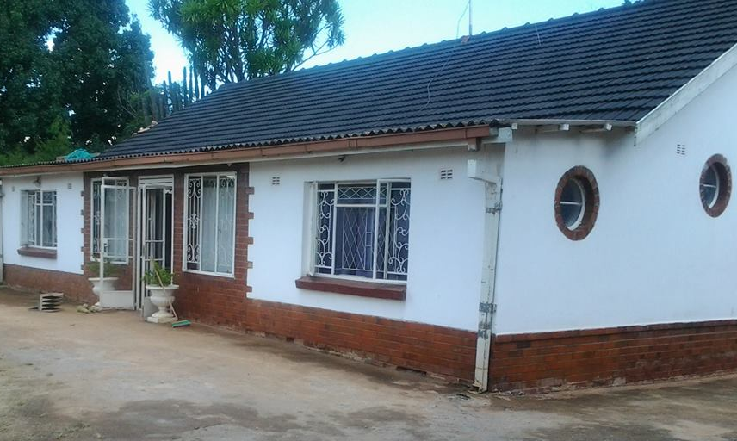
Consumer Council of Zimbabwe Head Office in Eastlea, Harare

CONSUMER EDUCATION

Consumer education programmes increased drastically in 2015 in all CCZ regions. A total number of 514 consumer education programmes continued to be carried out throughout the country. These included 269 focus desks, 103 outreaches to various communities, 48 outreaches to schools and tertiary institutions, 94 to Consumer Action Clubs. Some of the target places where consumer education activities were carried out in the regions are highlighted below:

Table 1: Areas where outreach programs were carried out in 2015

Region | Venue | Target Group
Mashonaland | Fife Avenue Shopping Mall, Pick ‘n’ Pay Kamfinsa Kensington Shopping Centre, TM Braeside, Chitungwiza, Budiriro, Orr & Harare Streets, Bon Marche Avondale, Arundel Spar, Borrowdale Brooke Spar, Strathaven, Montagu, OK First Street, Joina Complex, Mutoko.  Harare Anglican Cathedral, Chitungwiza, Ruwa, Hatcliffe, Dzivarasekwa,Sally Mugabe Heights  Churchill and Roosevelt High Schools | General public  Action Club Members  Students
Matabeleland | Bulawayo Centre, Nkulumane Shopping Mall, Entumbane Shopping Complex, Cowdry Park, Emgamwini, Bellevue Spar  Emakhandeni, Nkulumane, Esigodini  Nkulumane Primary School, Gwanda, Mpopoma, Njube, Msiteli, Magwegwe, St James, Tsholotsho High Schools, | General public  Action Club members  Students
Midlands | Midlands State University, Gweru Polytechnic College, Zimbabwe Open University, Fletcher, Thornhill, Mkoba, Chaplin High Schools,  Lower Gweru, Mkoba, Kwekwe Community Hall, Chiwundura  Senga, Nyaningwe, Batanai, OK and TM Supermarket | Students  Action Club members  General Public
Masvingo | Chicken Inn, Wimpy, Diyo, Aminas, Stop Over, Bilcro, Building Brigade, Nemanwa, Gokomere, Bhuka, Zishumbe, Siding shop  Chisungo A, B, C, Shine, Kushinga, Shingiso  Rujeko, Dikwindi, Don Bosco, Masvingo High, Masvingo & Morgenster Teachers’ Colleges, Great Zimbabwe University, Masvingo Polytechnic College | General public  Action Club members  Students
Manicaland | Chikanga, Mutare Hall, Himalaya, Sakubva  TM CBD, Meikles Park, Zimpost Mutare, Sakubva, Cost It Enterprise, Mega Market, Manica Post, Zepps Supermarket, Bata, Dangamvura | Action Club members  General Public

Figure 1: Consumer Education in 2014 and 2015

TOPICS COVERED DURING CONSUMER EDUCATION CAMPAIGNS
1. Consumer Rights and Responsibilities
2. Functions and services of the CCZ
3. Complaints Handling Process
4. Patients’ Charter
5. Consumer Action Clubs
6. History of CCZ and benefits of being a CCZ member
7. Consumer Protective Legislation
8. World Consumer Rights Day celebrations on “Consumers’ Right to Healthy Food”.
9. Your rights and responsibilities as a tenant
10. What to expect in a contract
11. Effects of impulsive buying
12. Shopping wisely
13. Consumer Protection Bill

GENERAL QUESTIONS RAISED DURING CONSUMER EDUCATION
The following were some of the most frequently asked questions by consumers:
1. Why is municipal police arresting vendors as, vending is sustaining the
livelihoods of some families?
- What is CCZ doing with the sale of counterfeit cell phone gadgets that have no
guarantees that is now rampant?
3. What are the benefits of becoming a CCZ member?
4. Persistent power outages are a cause of concern as they disrupt our learning
programmes, how can CCZ intervene?
5. City Council bills are unrealistic; can CCZ assist in seeking redress?
6. CCZ should spearhead the formation of student clubs from primary level up to
tertiary institutions so as to catch membership at an early age.
7. What is CCZ doing about disclaimer clauses?
8. What procedures should be followed when forming a Consumer Action Club?
9. What measures has Consumer Council put in place to ensure that consumer rights are being observed?
10. Consumers need to be educated on ‘best before dates’ of products they buy.

14. MEDIA PUBLICITY
The relations between the National media and CCZ are strong. Opportunities were proliferate throughout the year to ensure that consumer education had an outlet through the diverse media available to CCZ. Below are the programs that CCZ partook.

Live Radio Programs
1. Consumer Rights and Responsibilities
2. World Consumer Rights Day
3. History and functions of the CCZ
4. Consumer Protection Bill

Newspaper Articles

- World Consumer Rights Day Celebrations
- Consumer Protection Bill Consultations
- How to take your own case to court
- Benefits of becoming a member
- Credit worthiness
- Guide to your rights and responsibilities
- Public consultation needed on demonization
- Aggressive education needed on bond coins
- Street Vending Getting Out of Control
- Protect the health of your children

Television Interviews

- World Consumer Rights Day Celebrations

FOCUS DESKS
Focus Desks are information desks set by CCZ staff at points where there is increased consumer traffic like at shopping malls where they meet directly with the public, discussing and imparting knowledge about consumer issues. The CCZ regional offices continued to carry out consumer education though Focus Desks to increase the visibility of the organisation and also to provide consumers with an opportunity to learn more about the CCZ, consumer rights and responsibilities. Staff gave consumer education to consumers going about their business and answered questions from the public. The processes resulted in increased consumer awareness.

Figure 6: Focus Desks Carried Out in 2015

15. PROMOTIONAL ACTIVITIES

WORLD CONSUMER RIGHTS DAY
World Consumer Rights Day is an annual occasion for celebration and solidarity within the international consumer movement. It is time for promoting the basic rights of all consumers, for demanding that those rights are respected and protected, protesting the market abuses and social injustices which undermine them.

World Consumer Rights Day 2015 was celebrated under the theme, “Consumers’ Right to Healthy Food”. All Regional Offices that is, Masvingo, Mashonaland, Manicaland, Matabeleland and Midlands commemorated the day through stakeholder workshops, farm tours and exhibitions. Some of the issues discussed included Genetically Modified Foods, product certification, food security and nutrition.
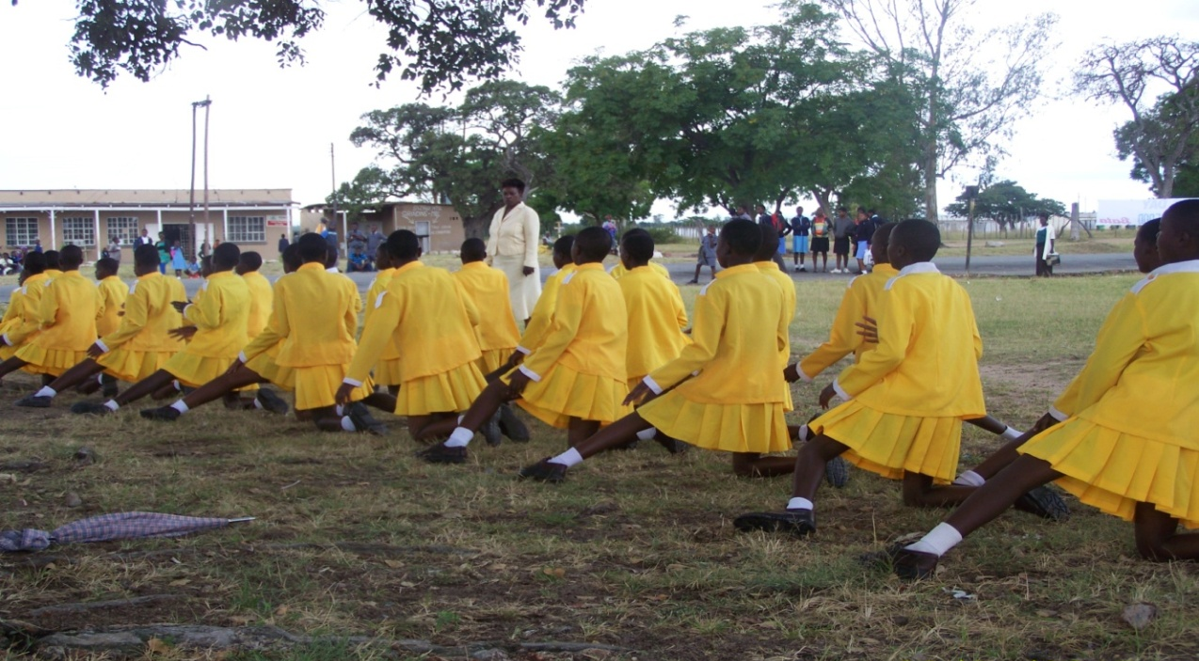
World Consumer Rights Day commemorations in Midlands

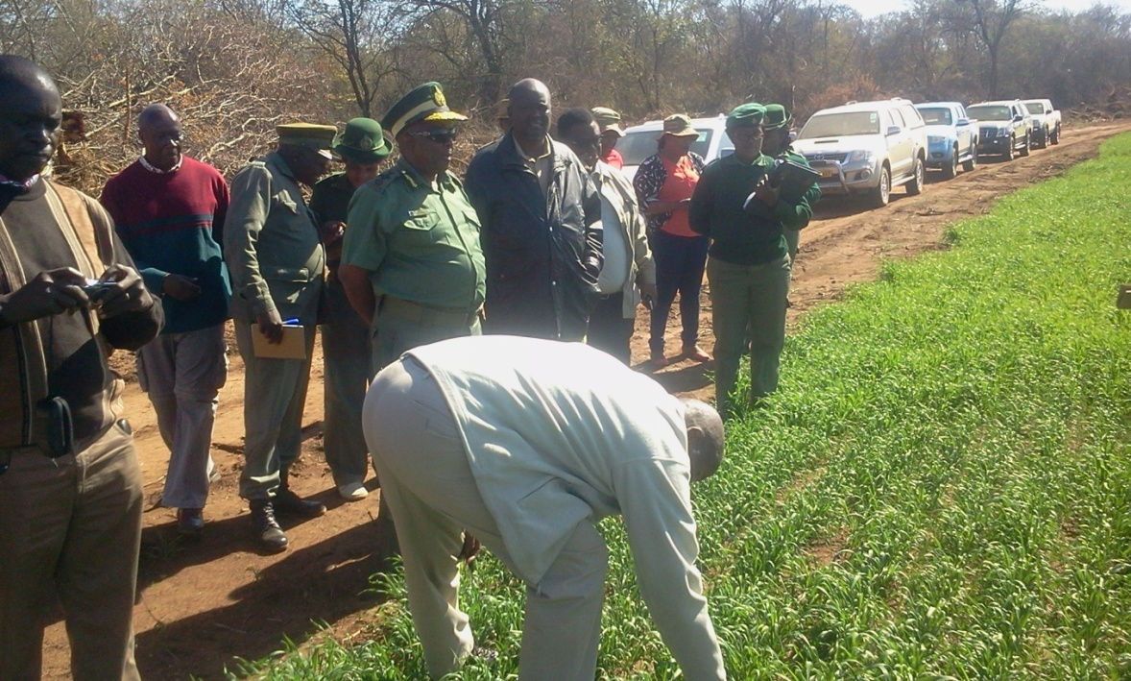
World Consumer Rights Day commemorations in Matabeleland

ZIMBABWE INTERNATIONAL TRADE FAIR
The CCZ exhibited at the 56th edition of the Zimbabwe International Trade Fair (ZITF) which ran under the theme, “Stimulating Trade, Seizing Opportunities to Accelerate Growth” from the 28th of April to the 2nd of May 2015. The CCZ’s

exhibition was under the Ministry of Industry and Commerce stand, as part of CCZ’s strategy to reach out to as many consumers as possible. The Fair provided the organisation with an opportunity to educate consumers about what the CCZ does, as well as networking with other organizations.
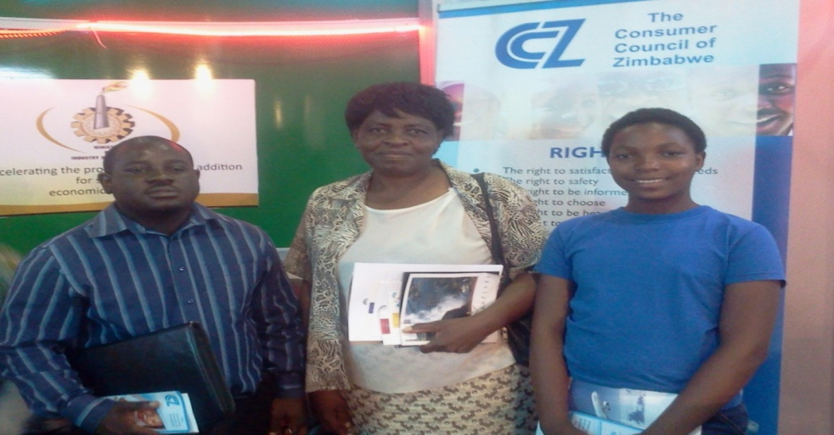
Participants at the ZITF Stand

- INTERNATIONAL WORKSHOPS

The Executive Director Miss Rosemary Siyachitema attended the 20th Consumers International (CI) World Congress which took place in Brasilia, Brazil from 18 to 21 November 2015 under the theme '’Unlocking Consumer Power: A new vision for the global marketplace'’ which was graced by over 700 delegates from all over the world. The event was packed with exciting and interesting panel sessions and interactive discussions across a range of significant consumer issues, all featuring experts from across the consumer movement, civil society organisations, government and the private sector. Delegates shared ideas and discussed new ways to advance their operations for greater global impact. Members from across the world also shared their amazing campaign success stories. Elections for new members took place, alongside a standing ovation for outgoing Council members. Congratulations to Miss Rosemary Siyachitema for being elected as one of the CI Board members at the Brazil Congress.

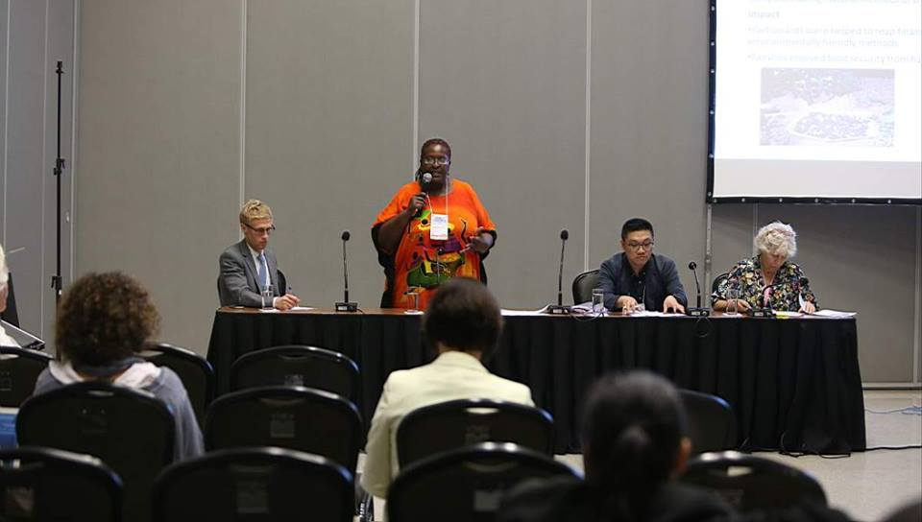
CCZ Executive Director, Rosemary Siyachitema presenting at the CI World Congress in Brazil

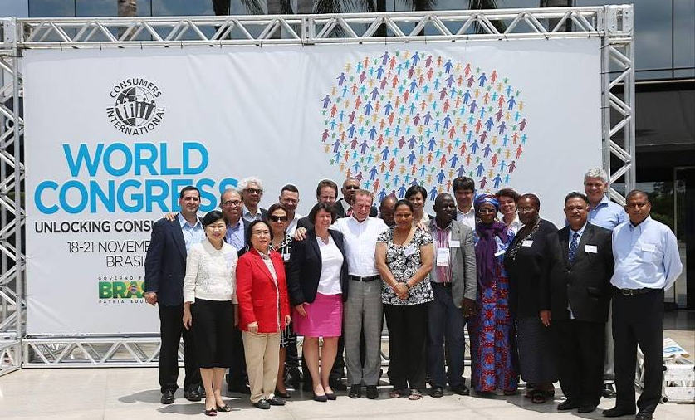
CI New Council Members

MEMBERSHIP

Recruitment of members remains the CCZ’s greatest challenge. Generally, consumers are struggling to make ends meet and therefore, they find it difficult to raise money to pay as membership fees. This inability to raise membership fees has had a bearing on membership recruitment. However, consumer education activities increased, because of the Consumer Protection Bill consultative workshops that were held in the country’s ten provinces, where the CCZ had the opportunity to speak to the public on consumerism and membership issues. By the end of 2015, 504 individual members were recruited nationally and 102 renewed their membership. Figure 6 below summaries the new membership recruitment activity in 2015.

Figure 7: Membership Recruitment for 2015

CONSUMER ACTION CLUBS (CACs)

The CCZ has used the Consumer Action Clubs as a catalyst for membership growth. The intention of CCZ is to grow such clubs all round the country and use these to distill consumer education and information and also as advocacy and pressure groups. During the period under review, clubs were trained in organic farming and on farming as business. A graduation ceremony was held on the 29th of April 2015 for all participants who completed the training. At the ceremony all CACs were encouraged to renew their membership and also mobilise other consumers to join as members. Consumer Action Clubs were also trained in indigenous chicken rearing.

Consumer Action Clubs Graduation Ceremony

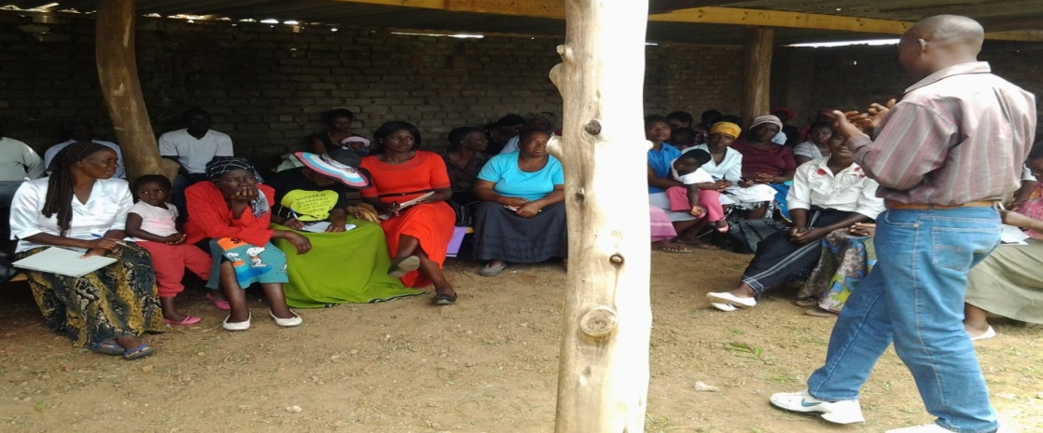
Consumer Action Club members receiving training on indigenous chicken rearing

- COMPLAINTS HANDLING & RECOVERIES FOR 2015

Complaints resolution is one of the CCZ broad objectives and a core competence area for the five regional complaints departments located in the five main provincial cities through the country. For the period under review regional complaints offices were inundated with complaints that ranged from service provision by utility providers, to repairs and contracts of sale involving shoddy goods. The use of alternative dispute resolution mechanisms has made us effective in resolving disputes that would have been congesting the formal courts.

More than 400 complaints were recorded in five regions. Complaints on contracts recorded the highest percentage of 22 percent followed by shoddy goods and services that recorded 14 percent. Complaints on economic structures were
the least recording 0.75 percent. Under broad category 4 and 5 the highest number of transactions require parties to enter into written and verbal terms of contracts. These terms of contracts are either drafted in a legal jargon that is not understood by a layman or terms are entered into upon a customer receiving a receipt from the till. The CCZ is doing more to educate consumers on issues involving contracts.

Table 4: Complaints Handled in 2015 by all CCZ Regions

COMPLAINTS CATERGORIES AND NO. OF COMPLAINTS
NAME OF REGION | ADVERTISING (BC1) | ACCOMMO  DATION (BC2) | ECONOMIC STRUCTURE (BC3) | CONTRACTS (BC4) | SHODDY GOODS  (BC5) | REPAIRS (BC6) | HEALTH & SAFETY (BC7) | MISC  (BC8)
Mashonaland | - | - | - | 3 | 10 | 8 | 1 | -
Midlands | - | 7 | - | 36 | 27 | 5 | 10 | 11
Matebeland | 2 | 11 | 3 | 21 | 7 | 11 | 3 | -
Manicaland | 1 | - | - | 9 | 2 | 1 | - | -
Masvingo | - | 1 | 4 | 19 | 10 | 6 | 9 | -
Total | 3 | 19 | 7 | 88 | 56 | 31 | 24 | 11

Figure 9: Categories of Complaints Handled in 2015

Key
BC – Broad Category
BC1 Advertising (Misleading; Poor Labelling; Open dates)
BC2 Accommodation (Rent disputes; Building Contracts; Real Estates)
BC3 Economic Structures (Price disparities; Conditional Selling; Pricing and
Sales)
BC4 Contracts (Unfulfilled agreements; Unfair Contracts; Hire Purchase; Breach of Contracts; Loans; Debts; Lay byes; Disclaimer clause; Selling contracts)
BC5 Shoddy Goods (Furniture; Electrical gadgets; Clothing; Utilities; Back up spares)
BC6 Repairs (Vehicle repairs; Electrical repairs; Other repairs)
BC7 Healthy and Safety (Food and beverages; Drugs; Hairdressing; Medical Expenses)
BC8 Miscellaneous

LOBBYING AND ADVOCACY

Lobbying and Advocacy remained an integral part of the work of CCZ. The following were some of the activities that were carried out during the year under review: -
- 2016 Budget

- Participating in boards and committees

During the course of the year, CCZ staff continued to serve on various boards and working committees of other organizations that seek to protect the rights of the consumer.

Stakeholder Boards and Committees
CCZ staff were the voice of the consumer at the following boards and committees:
- Zimbabwe Women Resource Centre Network
- Health Professions Authority
- Food Standards Advisory Board
- Food Fortification Committee
- Standards Association of Zimbabwe
- Pharmacist Council
- Medicines Control Authority of Zimbabwe
- Livestock and Meat Advisory Board
- Buy Zimbabwe Board
- Rent Board
- Agricultural Marketing Authority

CONSUMER PROTECTION BILL

The organisation continued with the nationwide sensitization and consultative
programme in response to the proposed Consumer Protection Bill which was
launched by the Minister of Industry and Commerce Minister Bimha in 2014. The
areas that were covered in 2015 included Mutare, Masvingo, Mutoko and Harare. A
national stakeholder meeting was held in Harare to wind up the consultative
process.

The Bill was applauded as being a step of progress towards the consolidation and strengthening of consumer protection mechanisms. The Bill also establishes a Consumer Protection Commission as well as a Consumer Court which will allow consumers to get legal redress directly from a court system which is specialised in consumer issues.

Public participation encourages a sense of responsibility or ownership for a policy, programme or project. When people take an active part in policy formulation, the planning and or implementation of programmes or projects, they consider such policies, programmes and projects to be collectively their own, and therefore the public takes pride in such initiatives which lead to the sustainability of such initiatives. The concept of Public participation in Government processes has been institutionalised and legislated in most democracies and is generally recognised as a constitutional right.

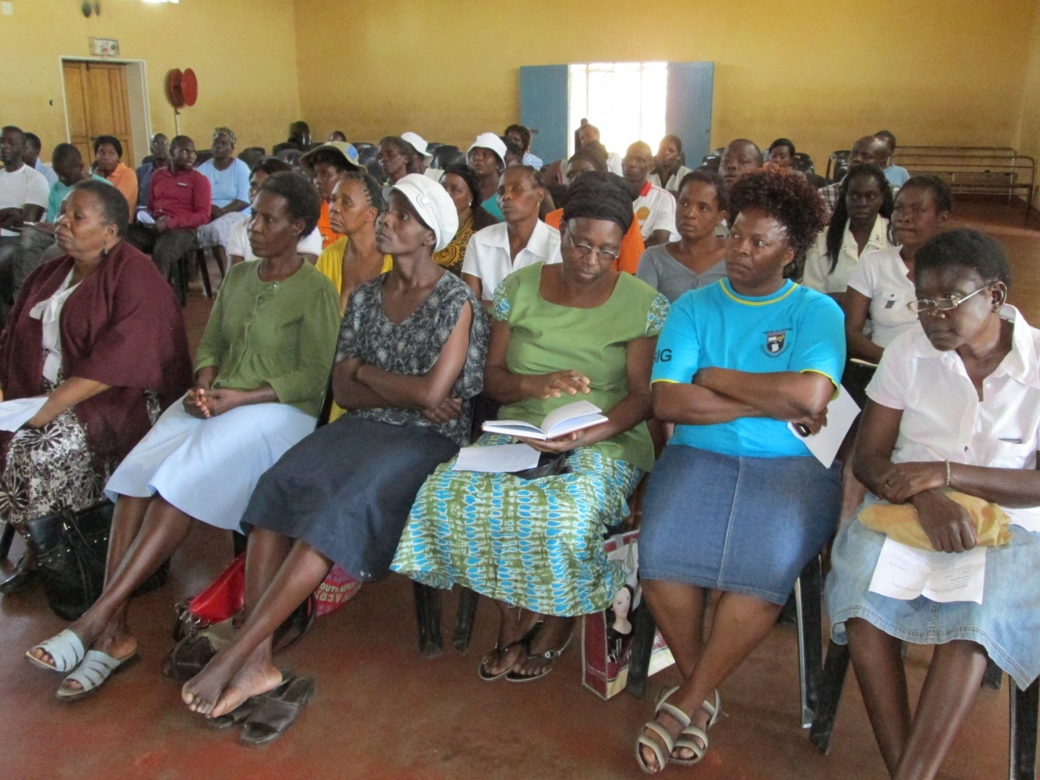
Consumer Protection Bill consultative meeting in Chiwundura, Midlands Region

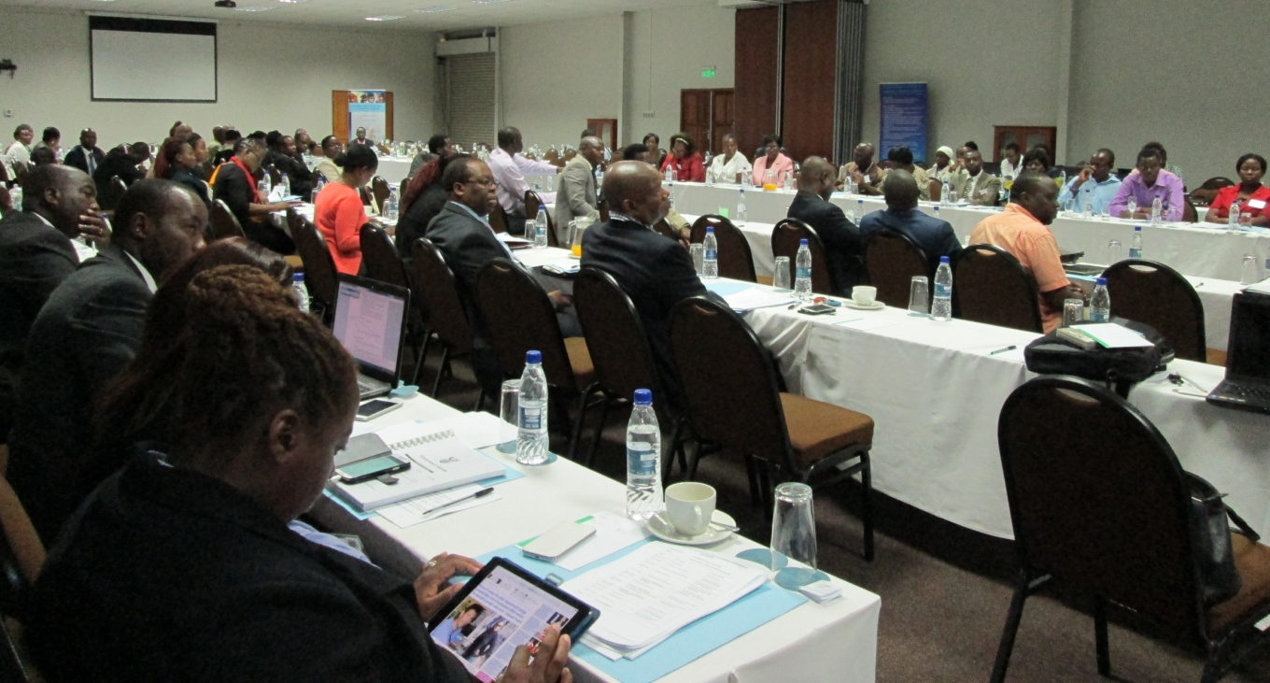
Participants following proceedings at the National Stakeholders meeting held in Harare

- CONTACT DETAILS

HEAD OFFICE Mashonaland Region
35 Rhodesville Road 35 Rhodesville Road
Eastlea Eastlea
Harare Harare
Tel: 263-04-496478/9 Tel: 263-04 -496478/9
Toll Free No: 08003 222 280

Matebeleland Region Midlands Region
109 – 110 Lutheran House 2nd Floor Cabs Building
Cnr L. Takawira Street/H. Chitepo Robert Mugabe Way
P.O Box 1978 P. O Box 619
Bulawayo Gweru
Tel/Fax: 263 –09-69058/661652 Tel: 263 54 221061
Tel/Fax: 263-054-221061

Masvingo Region Manicaland Region
136 Robertson Street Office 6 and 7
No. 3 Dault Street ZIMPOST Building
P. O. Box 386 P. O. Box 1008
Masvingo Mutare
Tel/Fax: 263 –039-64748 Tel/Fax: 263-020-64449
Website: www.ccz.org.zw

